**SigFx**

A how-to guide

Welcome to the wild world of effects in Signal Studio’s SigFx. Used to create particle systems out of billboarded quads and now with support for using pre-existing .sigml, .mshml or even .fxml files as ‘particles’.

By starting a new FxFile, (extension .fxml ) a new effect scene is created. Within the scene any number of particles systems, mesh systems and particle attractors can be placed, translated, scaled and rotated. Once placed, effect systems are manipulated by changing system-specific settings shown in the right-hand panel of SigFx; in addition there are a series of graphs used to represent specific control values specific to each system that can change over time.

The layout of an FxFile is like so:

* FxFile – an explosion effect
  + Particle System 01 - fireball
  + Particle System 02 – smoke
  + Particle System 03 - sparks
  + Mesh System – dirt chunk mesh debris
  + Attractor 01 – gravity on the dirt chunks

**Using Graphs:**

Graphs are used to handle control of system properties that can vary in value over time. Examples of these are the rate of spawning new particles, the size and color of particles or how much force of gravity an attractor has. In each graph, the x-axis represents time and the y-axis represents the value of the system property at time *t*.

The x-axis of the graph (time) is given in a fixed range of: [0...1]. Most graphs will match this with the duration of the scene-time, while others match this to the lifetime of each individual particle itself. Note: If the x-axis is per-particle based then the graph name will be followed by an asterisk (*).

You will notice some graphs have keyframes with more than one node representing the value of said keyframe. These are used to represent 2D, 3D and 4D graph nodes, such as the x and y scale of a mesh, or the red, green, blue and alpha components that make up a particles color.

**Using Attractors:**

Attractors are used in conjunction with particle and mesh systems to simulate a force acting on individual particles within each system. An attractor can act as one of three different forces: **attract**, **repel**, or **gravity**. In the first two types of force, the strength of the force is inversely proportionate to the distance between the attractor and the individual particle. These two forces are modeled on the behavior of two bodies in space attracting each other with their gravitational pulls. The third force, **gravity**, is an all-encompassing force and will act on any particle the same no matter the distances between particle and attractor.

Attractors are useful for creating effects that require the motion of particles to swirl or move in a non-linear fashion. Especially good for muzzle-blasts and spell-effects!

Graph Context Menu Help: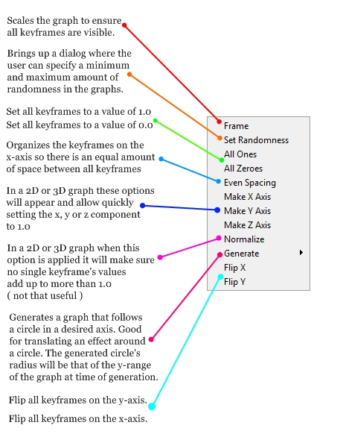

Toolbar Overview:

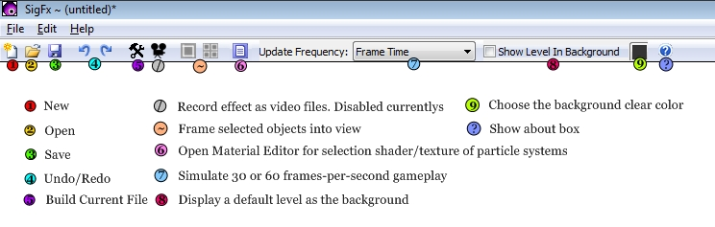

Right Hand Side Controls Overview:

